**CHEM 8B, Lecture 17 – Lipids**

- Fatty Acids & Triacylglycerols

- Saponification, AKA Basic Hydrolysis

- Phospholipids

- Just for fun: terpenes & cannabinoids

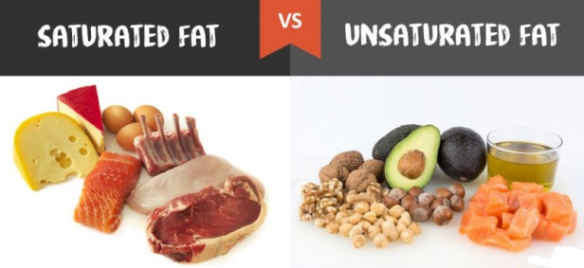

- No Alkenes - 1+ alkenes (typically *cis*)

- Solids – animal fat (ex. Butter) - Liquids – vegetable oils





**Triacylglycerols** = stored fats





*Draw a triacylglycerol formed from the following fatty acids…*

oleic (18 C Ω-9-unsat), myristic (14C sat.), and palmitic (17 C Ω-7-unsat) acids

**SAPONIFICATION** = Basic hydrolysis of triacylglycerols = making soap





Detergent ≠ Soap

**Phosphoesters & Phospholipids**



*Draw a phospholipid from these components…*



**Phosphates** = Nature’s best leaving groups



**Cannabinoids** – marijuana components



Q&A Session tomorrow @ 10am

Final Exam Friday

- Cumulative (except no Chapter 18 chemistry – ethers & epoxides)